FUNCTIONAL REQUIREMENTS DOCUMENT

30 may 2025

LEARning management system FOR SYS college

**zohaib waqar**

ex dev & Technical business analyst

Table of Contents

**Author Change Control & Approvers2**

**Executive Summary2**

**Glossary2**

**User Personas2**

**Business Goals2**

**Project Overview & Objectives3**

Overview3

Objectives3

**Project Scope3**

In Scope3

Out of Scope3

**Success Criteria4**

**Current State4**

**Target State4**

**RAID (Risks, Assumptions, Issues, Dependencies)4**

**Major Requirements4**

Must Have4

Should Have5

Could Have5

Won’t Have6

Use Case Description6

**Business Rules7**

**Data Privacy & Security Requirements8**

**Accessibility Considerations** **8**

**Business Process Flow8**

**Reports & KPI8**

**Reference Documents8**

**Project Schedule (High-Level Milestones)9**

1. **Author Change Control & Approvers**

|  |  |  |  |  |
| --- | --- | --- | --- | --- |
| # | version | Date | Author | description |
| 1 | 1.0 | 30 May 2025 | Zohaib Waqar | Initial Draft |

**Reviewed By:** [Reviewer Name Here]

**Approved By:** [Approver Name Here]

1. **Introduction**
   1. **Purpose**

The purpose of this document is to define the functional requirements of the Learning Management System (LMS) being developed for Sys College. This system is intended to support the institution's strategic goal of improving teaching effectiveness, enhancing the student learning experience, and streamlining academic operations. The FRD translates business needs into detailed functional specifications that will guide the design, development, and testing of the LMS.

This document serves as a foundation for alignment among business stakeholders, the development team, QA, and implementation teams. It ensures all functional expectations are clearly defined, traceable, and testable.

* 1. **Scope**

The LMS will serve as a centralized digital platform to manage and deliver academic content, facilitate communication between students and faculty, automate grading and feedback workflows, and provide data-driven insights to department heads and executives.

The system will provide secure access for various user roles including students, faculty, administrative staff, and department heads, as well as integrations with external systems such as the Student Information System (SIS), Active Directory (for authentication), and Turnitin (for plagiarism detection). The LMS will support core academic activities such as course creation, content management, assignment submissions, performance tracking, and reporting.

This document outlines the functionality required in the initial release. Non-functional aspects such as performance, scalability, and security are addressed at a high level but may be expanded in supporting documents.

1. **Glossary**

|  |  |  |
| --- | --- | --- |
| # | Term | definition |
| 1 | LMS | Learning Management System |
| 2 | SIS | Student Information System |
| 3 | RBAC | Role-Based Access Control |
| 4 | SSO | Single Sign-On |
| 5 | KPI | Key Performance Indicators |

1. **Functional Requirements**

The functional requirements for the Learning Management System (LMS) at Sys College are derived from stakeholder interviews and business goals identified in the Business Requirements Document (BRD). These requirements define how the system should behave in support of core academic and administrative processes. The LMS will support the following high-level functional capabilities:

* 1. **User Management**

Secure registration, login, and role-based access control for students, faculty, admin staff, and department heads, leveraging integration with Active Directory for authentication.

**Description:** Handles user registration, login, authentication, and role-based access.

|  |  |
| --- | --- |
| Requirement ID | Requirement Description |
| UM-01 | The system shall allow users to register based on role (Student, Faculty, Admin, Dept Head). |
| UM-02 | The system shall authenticate users via Single Sign-On using Active Directory. |
| UM-03 | The system shall enforce Role-Based Access Control (RBAC) to limit access by user type. |
| UM-04 | The system shall provide a “***Forgot Password***” feature integrated with institutional email. |

* 1. **Course Management**

Faculty can create, update, and manage course structures, including uploading and organizing digital learning materials.

**Description:** Enables faculty to create, configure, and manage courses.

|  |  |
| --- | --- |
| Requirement ID | Requirement Description |
| CM-01 | The system shall allow faculty to create new courses with title, description, and schedule. |
| CM-02 | The system shall enable faculty to upload, organize, and update course content. |
| CM-03 | The system shall support version control for content updates. |
| CM-04 | The system shall allow faculty to archive or delete obsolete courses. |

* 1. **Student Enrollment & Scheduling**

Admin staff will enroll students into courses and manage academic schedules, with data synchronization from the Student Information System (SIS).

**Description:** Allows admin staff to enroll students and manage academic schedules.

|  |  |
| --- | --- |
| Requirement ID | Requirement Description |
| ES-01 | The system shall allow admin staff to enroll students manually or via SIS sync. |
| ES-02 | The system shall import course rosters and schedules from the SIS. |
| ES-03 | The system shall enable admin to assign faculty to courses. |
| ES-04 | The system shall provide calendar-based schedule views for each user type. |

* 1. **Content Delivery & Interaction**

Students will be able to view assigned courses, access content, participate in discussions, and receive real-time notifications.

**Description:** Supports content access, learning activity, and communication for students.

|  |  |
| --- | --- |
| Requirement ID | Requirement Description |
| CD-01 | The system shall display a dashboard of enrolled courses to each student. |
| CD-02 | The system shall allow students to view/download course content. |
| CD-03 | The system shall allow students to receive notifications on assignments and updates. |
| CD-04 | The system shall support responsive design for mobile and tablet access. |

* 1. **Assignment & Grading Workflow**

Faculty can create and manage assignments, while students can submit work through the LMS. Faculty can grade submissions, provide feedback, and use Turnitin integration for plagiarism detection.

**Description:** Manages submission, grading, feedback, and plagiarism checking.

|  |  |
| --- | --- |
| Requirement ID | Requirement Description |
| AA-01 | The system shall allow faculty to create, edit, and assign coursework or assessments. |
| AA-02 | The system shall allow students to submit assignments through the portal. |
| AA-03 | The system shall integrate with Turnitin to check plagiarism on submitted work. |
| AA-04 | The system shall allow faculty to provide grades and written feedback. |

* 1. **Dashboards & Analytics**

Department heads and executives can view performance dashboards showing trends in student engagement, course outcomes, and faculty activity.

**Description:** Provides dashboards and data insights to faculty, admin, and executives.

|  |  |
| --- | --- |
| Requirement ID | Requirement Description |
| AR-01 | The system shall display dashboards showing student performance and attendance. |
| AR-02 | The system shall allow department heads to view aggregated academic data. |
| AR-03 | The system shall generate reports on course progress, grading distribution, and compliance. |
| AR-04 | The system shall export reports in PDF and Excel formats. |

* 1. **Compliance & Reporting**

Admin staff can monitor attendance, submission compliance, and generate reports to support accreditation and internal audits.

Each of these capabilities will be further detailed in the following sections of this document, including use case flows, input/output definitions, and business rules.

**Description:** Provides Reporting tools with export feature to faculty, admin, and executives.

|  |  |
| --- | --- |
| Requirement ID | Requirement Description |
| CR-01 | The system shall generate reports on course progress, grading distribution, and compliance. |
| CR-02 | The system shall export reports in PDF and Excel formats. |

1. **User Roles & Permissions**

|  |  |
| --- | --- |
| user Roles | Permissions |
| Admin Staff | * Enroll students into courses * Create and manage course schedules * Monitor compliance reports * Manage user accounts for students/faculty |
| Faculty | * Create and manage courses * Upload and organize learning materials * Assign, grade, and provide feedback on assessments * View student progress within their own courses |
| Student | * Register and login to the system * View enrolled courses * Access course content * Submit assignments * View grades and feedback |
| Department Head | * Access dashboards with department-wide data * Analyze academic performance * Monitor faculty activity and student trends |
| External Systems | * **Active Directory:** Handle authentication * **SIS:** Sync student enrollment and course data * **Turnitin:** Process assignment plagiarism checks |

* 1. Deliver a superior student learning experience
  2. Increase teaching quality and academic effectiveness
  3. Support data-driven decision-making across departments
  4. Streamline academic and administrative operations
  5. Enable digital and remote learning across campuses

1. **Project Overview & Objectives**
   1. **Overview**

The LMS project is part of Sys College's strategic vision to lead in teaching excellence. The system will centralize learning activities, enable performance tracking, and improve communication among faculty, students, and administrators.

* 1. **Objectives**
     1. Implement a cloud-based LMS with role-based access
     2. Provide integration with SIS, Active Directory, and HRMS
     3. Enable dashboards for monitoring engagement and performance
     4. Support mobile and offline access to content
     5. Automate grading, attendance, and notifications

The system’s high-level data flow and boundaries are illustrated in the System Context Diagram (**see Appendix ‘A’**)

1. **Project Scope**
   1. **In Scope**
      1. Centralized content management and learning modules
      2. Assignment submissions and grading workflows
      3. Real-time dashboards and analytics
      4. Mobile and offline access
      5. Integration with core systems (SIS, AD)
      6. Role-based access and permissions
   2. **Out of Scope**
      1. Physical infrastructure upgrades
      2. Third-party course content creation
      3. External certification or accreditation platforms
2. **Success Criteria**
   1. **85%** adoption rate within one academic term
   2. Reduction in grading and reporting time by **40%**
   3. Student satisfaction score improvement by **25%**
   4. **Real-time visibility** of academic KPIs
3. **Current State**
   1. Fragmented tools: emails, shared drives, physical materials
   2. Manual tracking of attendance, grading, and progress
   3. No unified view of course performance or engagement
4. **Target State**
   1. Centralized, secure LMS platform with integrated tools
   2. Automated workflows and unified communication channels
   3. Role-specific dashboards for faculty, students, and executives
5. **RAID (Risks, Assumptions, Issues, Dependencies)**

|  |  |
| --- | --- |
| Type | Description |
| Risk | Resistance to change from senior faculty |
| Assumption | Staff and students will have basic digital literacy |
| Issue | Integration delays with legacy systems |
| Dependency | SIS, HRMS, AD system compatibility |

1. **Major Requirements**

The following section outlines the major system requirements for the LMS project using the **MoSCoW** **prioritization** method, along with the corresponding stakeholder sources. The system’s visual breakdown of the prioritization is illustrated in MoSCoW Prioritization Matrix (**see Appendix ‘B’**)

* 1. **Must Have**

These are critical requirements without which the system will not function as intended.

|  |  |
| --- | --- |
| Requirement | Source |
| Centralized course content repository for all departments | Academic Staff, Students |
| Assignment submission and automated grading workflows | Academic Staff, Students |
| Automated notifications for deadlines, grades, and announcements | Academic Staff, Students |
| Mobile-responsive design with offline access capability | Students |
| Role-Based Access Control (RBAC) to manage permissions | IT Department |
| Integration with Student Information System (SIS) and Active Directory (AD) | IT Department |
| Secure authentication with SSO and MFA | IT Department, Executives |
| Real-time dashboards for student performance and faculty activity | Department Heads, Executives |

* 1. **Should Have**

Important features that add significant value but are not essential at initial rollout.

|  |  |
| --- | --- |
| Requirement | Source |
| Attendance tracking through login/session logs | Admin Staff, Academic Staff |
| Course completion tracking for students | Academic Managers, Students |
| Messaging/chat system within the platform | Students, Academic Staff |
| Document version control for uploaded materials | Academic Staff |
| Basic plagiarism detection integration | Academic Staff |

* 1. **Could Have**

Desirable features that can enhance the user experience if time and budget permit.

|  |  |
| --- | --- |
| Requirement | Source |
| Peer review and collaborative group project tools | Students |
| Gamification elements (badges, leaderboards) | Students |
| AI-based recommendations for learning content | Executives |

* 1. **Won't Have (for now)**

These features are out of scope for the initial phase but may be considered in future enhancements.

|  |  |
| --- | --- |
| Requirement | Source |
| Integration with third-party MOOC platforms (e.g., Coursera) | Project Scope Decision |
| Fully automated course recommendation engine | Executive Interview, marked as future enhancement |
| External accreditation or certification workflows | Executive Team, marked out-of-scope |

The use case diagram (**see Appendix ‘C’**) outlines the major functional interactions between system users and the LMS. It highlights what actions each user role (e.g., Student, Faculty, Admin Staff, Executives, IT Department) can perform in the system, such as managing enrollment, submitting assignments, generating reports, and accessing materials.

* 1. **Use Case Description**
     1. **Common Use Cases (All Roles)**
* **Register** Allows users to create an account in the LMS (or be provisioned through integrated systems).
* **Login** Enables secure access to the LMS using credentials, often authenticated via Active Directory.
  + 1. **Admin Staff**
* **Enroll Student** Register new students into the appropriate courses and academic sessions.
* **Manage Schedule** Create and maintain class schedules, exam timetables, and resource allocations.
* **Monitor Compliance** Track attendance, course completion, and policy adherence across departments.
  + 1. **Faculty**
* **Create Course** Set up a new course in the LMS with basic structure and metadata.
* **Manage Course** Update course info, enrollment limits, session plans, and timelines.
* **Upload Content** Add learning materials such as slides, documents, and videos.
* **Manage Content** Organize, update, or archive existing course content.
* **Manage Grades** Enter, update, and release student grades and feedback.
  + 1. **Student**
* **View Content**  Access course materials, lectures, notes, and readings.
* **View Courses** See a personalized dashboard of all enrolled courses.
* **Submit Assignment** Upload assignments and track submission status and deadlines.
  + 1. **Department Heads**
* **View Dashboard** Access real-time data on faculty activity, student performance, and course status.
* **Analyze Performance** Review aggregated analytics to identify academic trends, gaps, and improvement areas.
  + 1. **External Systems (Actors)**
* **Authentication (Active Directory)** Secure user login via Single Sign-On (SSO).
* **Sync Students (SIS)** Import and update student data, enrollments, and academic records.
* **Check Plagiarism (Turnitin)** Automatically scan student submissions for originality and plagiarism detection.

1. **Business Rules**
   1. Only faculty can modify course content
   2. Students can view only their enrolled modules
   3. Attendance must be auto-logged for every session
2. **Data Privacy & Security Requirements**
   1. Compliance with GDPR and national education data policies
   2. Multi-factor authentication and SAML-based SSO
   3. Encrypted data storage and secure user sessions
3. **Accessibility Considerations**
   1. WCAG 2.1 compliant UI for visually impaired users
   2. Keyboard navigability and screen reader compatibility
   3. Mobile responsiveness
4. **Business Process Flow**

The Business Process Flow Diagram (**see Appendix ‘D’**) illustrates the end-to-end business process flow for the LMS at Sys College. It represents how various user roles interact with the system throughout the academic lifecycle, from course creation and enrollment to assignment submission, grading, and performance reporting. This flow integrates key external systems like SIS, Turnitin, and AD for seamless automation and secure access.

1. **Reports & KPI**
   1. Faculty performance dashboard
   2. Student engagement & retention reports
   3. Real-time grading summaries
   4. Assignment submission compliance
2. **Reference Documents**
   1. [Requirements Elicitation Document (dated: 03 May 2025)](https://github.com/ZohaibWaqarMalik/Technical-Business-Analyst-Projects/blob/main/02%20-%20LMS-SysCollege/01%20-%20Requirements%20Elicitation/01%20-%20Requirement%20Elicitation.pdf)
   2. [Stakeholder Interview Summaries (dated: 05 May 2025)](https://github.com/ZohaibWaqarMalik/Technical-Business-Analyst-Projects/blob/main/02%20-%20LMS-SysCollege/01%20-%20Requirements%20Elicitation/02%20-%20Requirements%20Elicitation%20-%20Questionaries.pdf)
   3. Appendix A: System Context Diagram
   4. Appendix B: MoSCoW Prioritization Matrix
   5. Appendix C: Use Case Diagram
   6. Appendix D: Business Process Flow
3. **Project Schedule (High-Level Milestones)**

|  |  |
| --- | --- |
| Milestone | Target Date |
| BRD Approval | [Insert] |
| System Design Completion | [Insert] |
| Development Start | [Insert] |
| User Testing | [Insert] |
| Go-live | [Insert] |

**Appendix A**

**SYSTEM CONTEXT DIAGRAM**

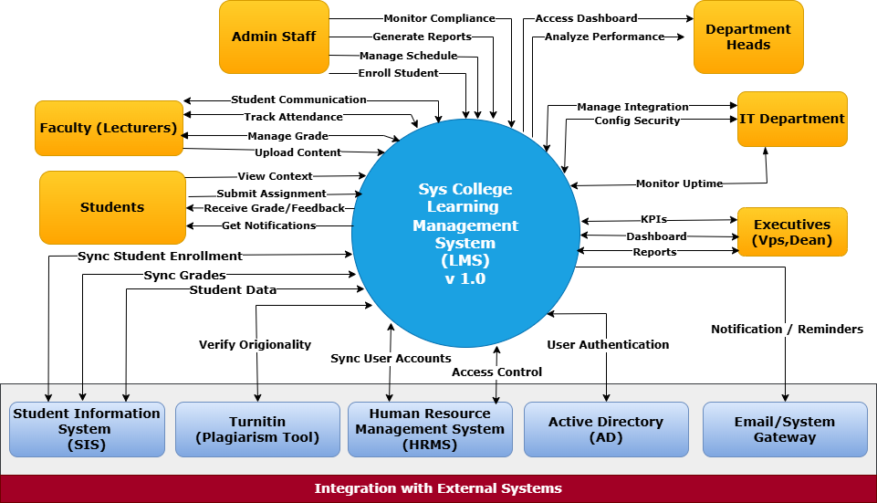

Fig A1: System Context Diagram

In the context diagram, the central system is represented as a single unit, with surrounding external entities connected via labeled data flows. These data flows indicate the main interactions, such as user requests, data submissions, or third-party API calls.

**Appendix B**

**MOSCOW PRIORITIZATION MATRIX**

|  |  |
| --- | --- |
| **MUST HAVE** | **SHOULD HAVE** |
| 1. Centralized course content repository for all departments 2. Assignment submission and automated grading workflows 3. Role-Based Access Control (RBAC) to manage permissions 4. Integration with Student Information System (SIS) and Active Directory (AD) 5. Real-time dashboards for student performance and faculty activity 6. Automated notifications for deadlines, grades, and announcements 7. Mobile-responsive design with offline access capability 8. Secure authentication with SSO and MFA   **Source:** Department Heads, Executives, Academic Staff, Students, IT Department | 1. Attendance tracking through login/session logs 2. Course completion tracking for students 3. Messaging/chat system within the platform 4. Document version control for uploaded materials 5. Basic plagiarism detection integration   **Sources:** Academic Staff, Admin Staff, Academic Managers, Students |
| **COULD HAVE** | **WON’T HAVE** |
| 1. Peer review and collaborative group project tools Gamification elements (badges, leaderboards) Source: Students 2. AI-based recommendations for learning content   **Source:** Students, Executives | 1. Integration with third-party MOOC platforms (e.g., Coursera) 2. Fully automated course recommendation engine 3. External accreditation or certification workflows   **Source:** Source: Project Scope Decision, Executive Team, marked out-of-scope |

Fig B1: MoSCoW Prioritization Matrix

This matrix categorizes business requirements using the MoSCoW method (Must Have, Should Have, Could Have, and Won’t Have) to clearly indicate priority and aid in project scope management.

**Appendix C**

**USE CASE DIAGRAM**

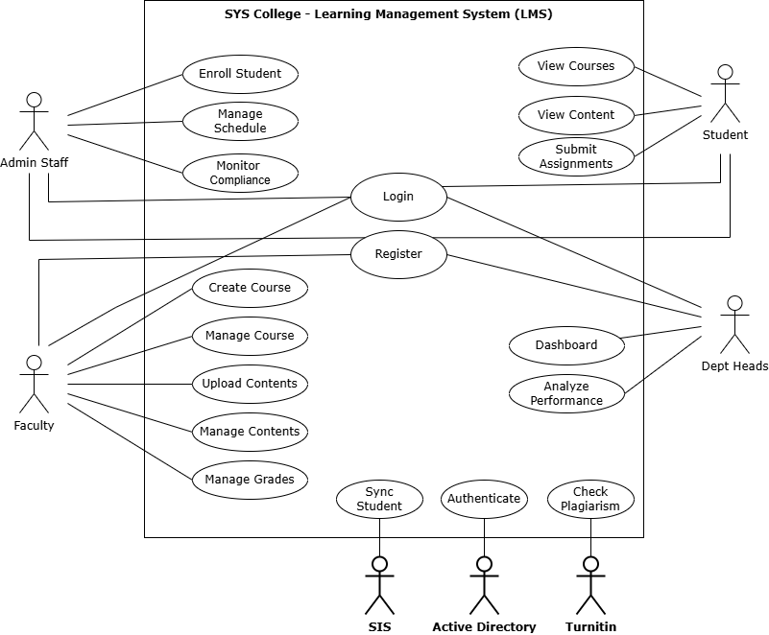

Fig C1: Use Case Diagram

This diagram visualizes the sequential interaction of faculty, admin staff, students and dept heads within the LMS, including integration points with external services such as SIS, Turnitin, and Active Directory.

**Appendix D**

**BUSINESS PROCESS FLOW**

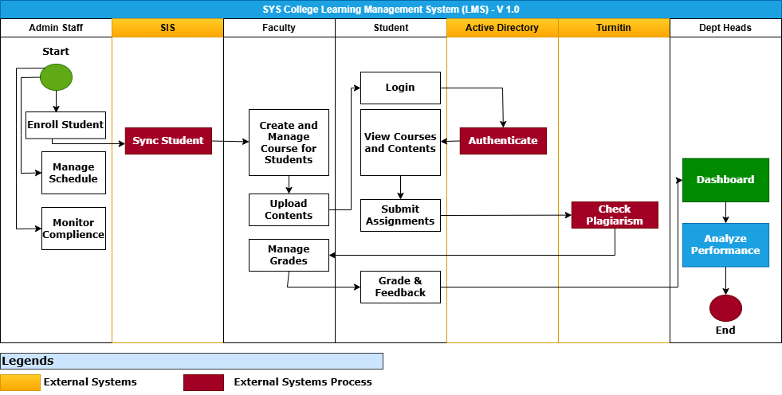

Fig D1: Business Process Flow – Swim Line Diagram

This diagram visualizes the sequential interaction of faculty, admin staff, students and dept heads within the LMS, including integration points with external services such as SIS, Turnitin, and Active Directory.